**Alpha Group**

Ashley Landin

Cody Ferre

Deandra Ash

Irene Carrillo Jaramillo

Samuel Segars

**Case Study Project**

**Milestone #1:**

Case Chosen: Bacchus Winery

Business Rules:

Bacchus has multiple Wines

Bacchus has multiple Suppliers

Bacchus has multiple Employees

One Employee has multiple Positions

Multiple Employee’s have multiple Hours

One Supplier has multiple Products

One Supplier has multiple Shipments

Multiple Shipments have One Supply

Multiple Wine’s have multiple Sales

One Distributor has multiple Sales 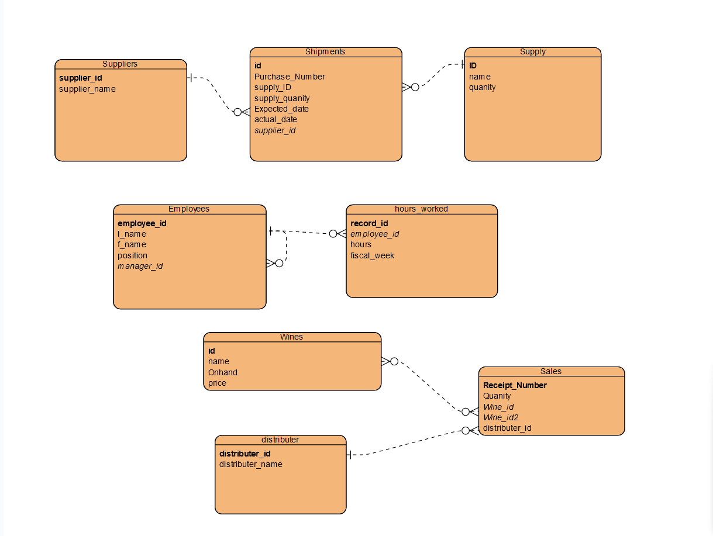

**Milestone #2:**

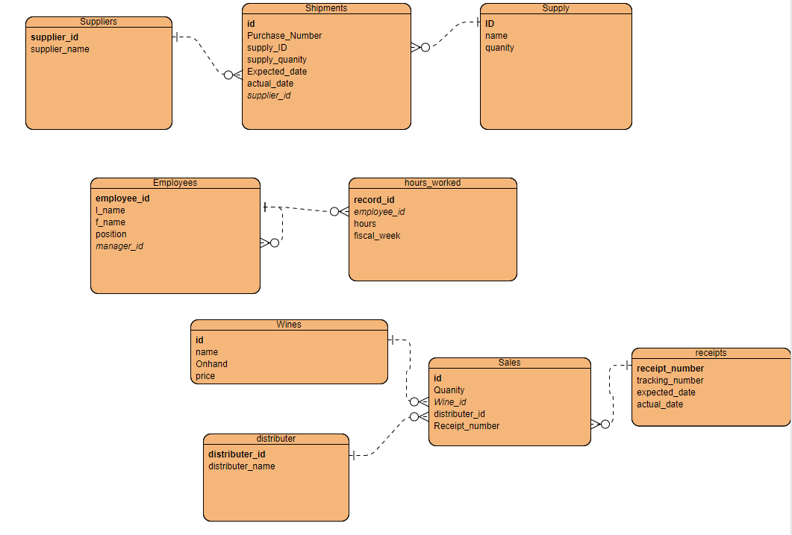

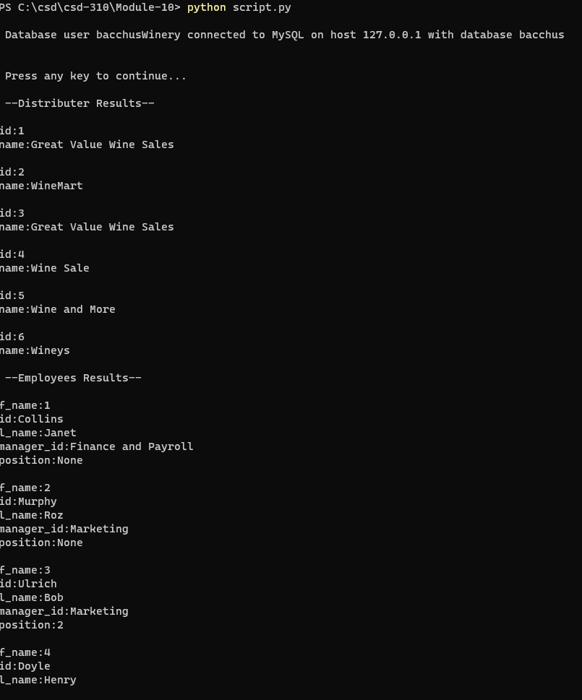





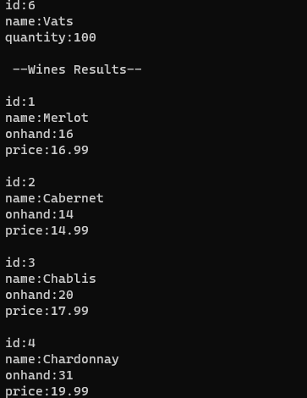

**Milestone #3:**

**Milestone #4:**

**Milestone #5:**